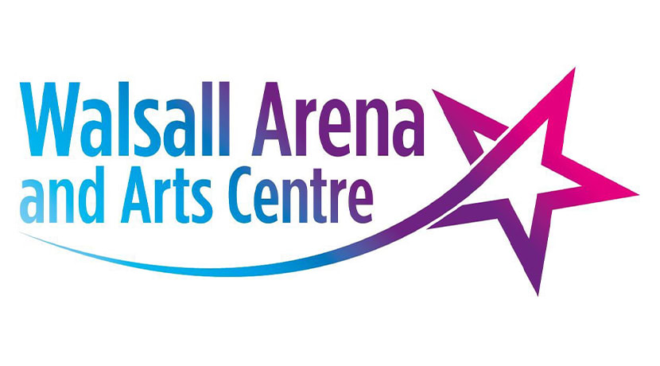
The Black Country Dance Hub
C/O Walsall Arena and Arts Center
Hawbush Rd
Walsall
WS3 1AG

AUTUMN COMMUNITY DANCE FESTIVAL
for
SCHOOLS, COLLEGE AND COMMUNITY GROUPS
@
WALSALL ARENA AND ARTS CENTRE
NOVEMBER 21st 7.00PM

Dear Colleague

Big News! We are excited to announce that the Autumn Community Dance Festival in partnership with Black Country Dance Hub is coming back to Walsall Arena and Arts Centre on November 21st at 7.00pm.

Schools, Colleges and Community Groups are all welcome to submit an application to be part of the first live festival since the pandemic with a live audience. We look forward to welcoming you back and celebrating the talents from children and young people across the Black Country and beyond.

How to apply:

- Please complete and return the attached entry form,

- Send me your music electronically (We don’t accept YouTube links) to Jodiestus@blackcountrydance.com before the entry deadline

- After the deadline you will be sent further information about the festival including how to purchase tickets.

- If you require further information or want to discuss the festival, please feel free to contact me via email or phone.

- Return the attached ENTRY Form to jodiestus@blackcountrydance.com by OCTOBER 14th, 2022nd, 4.00PM.
Yours sincerely

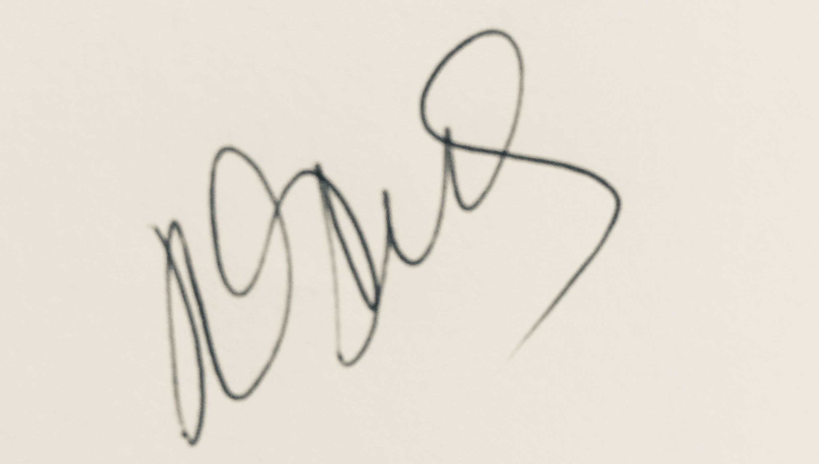

Jodie Stus - Coordinator
Black Country Dance Hub
Jodiestus@blackcountrydance.com
www.blackcountrydance.com 01922 656011 / 07403273846

BCDH in Partnership with Walsall Arena and Arts Centre

2022 AUTUMN COMMUNITY DANCE FESTIVAL
@
WALSALL ARENA AND ARTS CENTRE 7.00 PM
November 21st 2022

ENTRY FORM

Name of School/College/Group

Name of member of staff responsible

Contact email :
for member of staff responsible

Contact telephone:
for member of staff responsible

Year Group / or ages performing:

Number of performing dancers (MAX 30)
Title of Dance piece

Number of accompanying staff to the performance

Title of Music:
Composer/Artist of Music:
Length of performance
Maximum 4 minutes each group

Please describe any props you are using for your performance.

Return completed entry forms to jodiestus@blackcountrydance.com by October 14th 2022, 4:00pm

