The Black Country Dance Hub
C/O Walsall Arena and Arts Center
Hawbush Rd
Walsall
WS3 1AG

AUTUMN COMMUNITY DANCE FESTIVAL
for
SCHOOLS, COLLEGE AND COMMUNITY GROUPS
@
WALSALL ARENA AND ARTS CENTRE
NOVEMBER 17th 7.00PM

Dear Colleague

Exciting News! We are pleased to announce that the Autumn Community Dance Festival, in partnership with the Black Country Dance Hub at Walsall Arena and Arts Centre, is back on November 17th at 7.00pm.

Schools, Colleges and Community Groups are all welcome to submit an application to be part of this festival with a live audience. We look forward to welcoming you back and celebrating the talents from across the Black Country and beyond.

How to apply:

- Please complete and return the attached entry form.

- Send me your MP3 music file, electronically (We don’t accept YouTube links) to Jodiestus@blackcountrydance.com before the entry deadline.

- Good News! The BCDH now have a BOPA license. This now means you do not need to apply for a license yourself (conditions apply). However, the event still requires group leaders to provide the BCDH information about your young people.

- After the deadline you will be sent further information about the festival including how to purchase tickets.

- If you require further information or want to discuss the festival, please feel free to contact me via email or phone.

- Return the attached ENTRY Form to jodiestus@blackcountrydance.com by October 6th 2025, 4.00PM.
Yours sincerely

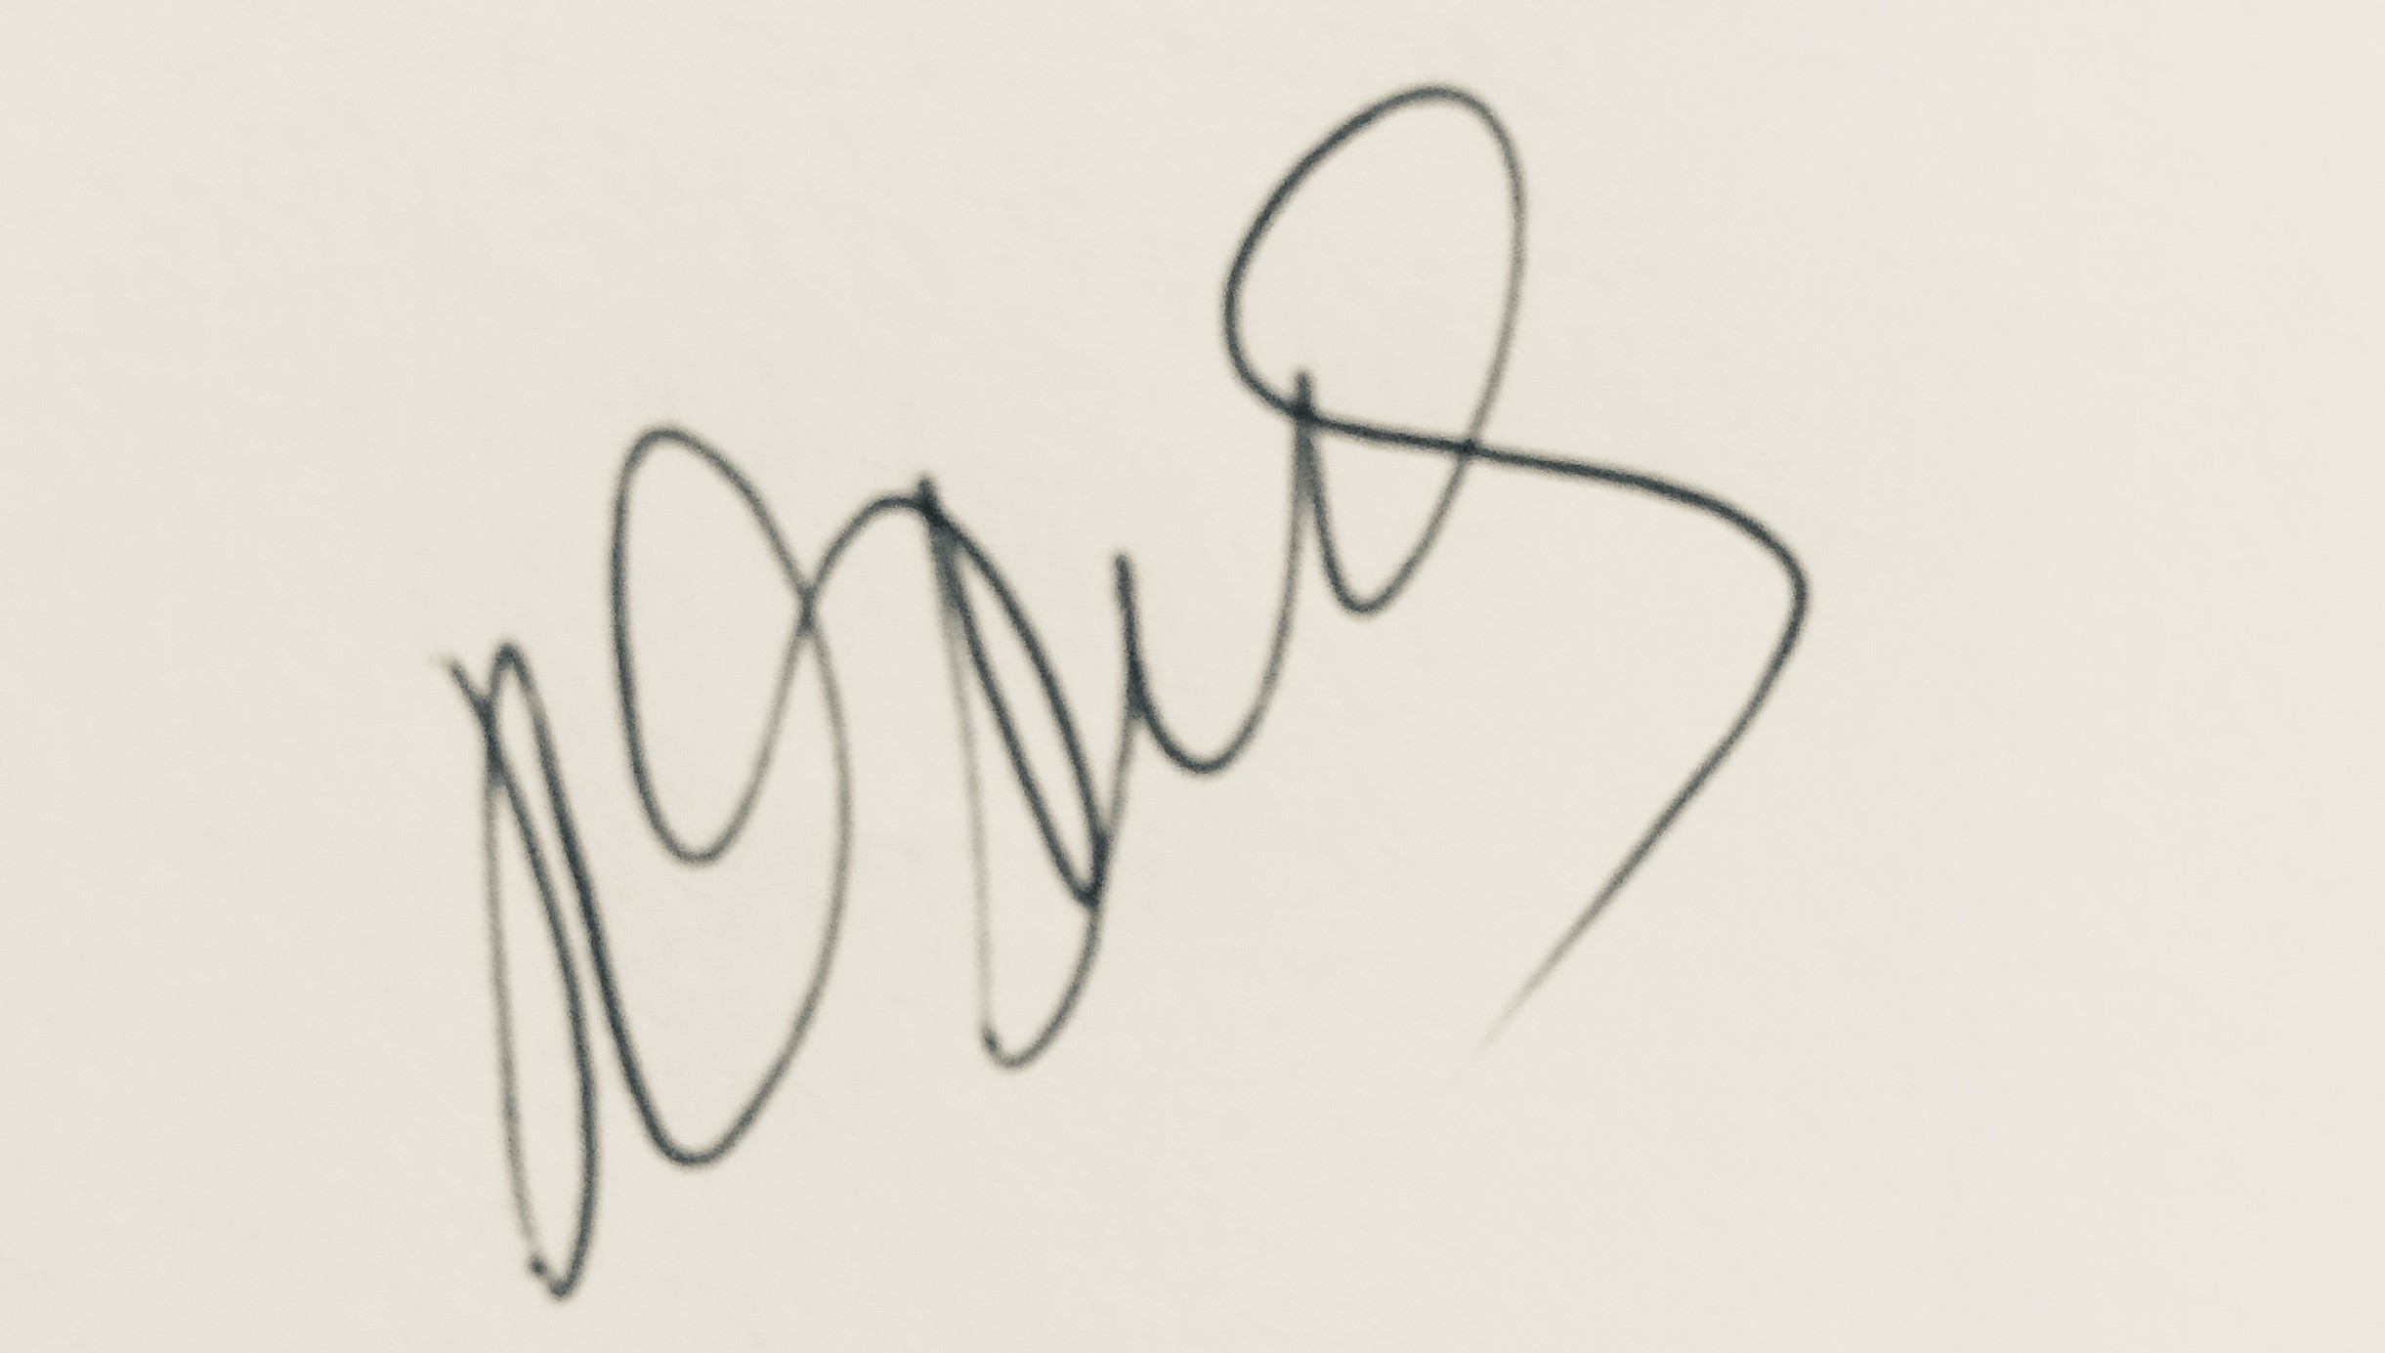

Jodie Stus - Coordinator
Black Country Dance Hub
Jodiestus@blackcountrydance.com; www.blackcountrydance.com 01922 656011 / 07403273846

BCDH in Partnership with Walsall Arena and Arts Centre

2025 AUTUMN COMMUNITY DANCE FESTIVAL
@
WALSALL ARENA AND ARTS CENTRE 7.00 PM
November 17th 2025

ENTRY FORM

Name of School/College/Community Group
Name of member of staff responsible
Contact email:
for member of staff responsible
Contact telephone:
for member of staff responsible
Year Group / or ages performing:
Number of performing dancers (MAX 30)
Title of Dance piece
Number of accompanying staff to the performance
Title of Music:
Composer/Artist of Music:
Length of performance
Maximum 4 minutes each group
Start on/off – provide brief details.
Finish on/off stage – provide brief details
Whole track used or Fade – please provide details
Please describe any props you are bringing/using for your performance.

Return completed entry forms to jodiestus@blackcountrydance.com by October 6th 2025, 4:00pm

